**DATA TECHNOLOGY SOLUTIONS**

**LAB 1D**

**GROUP A**

* Running Hortonworks Sandbox on Virtual Machine.

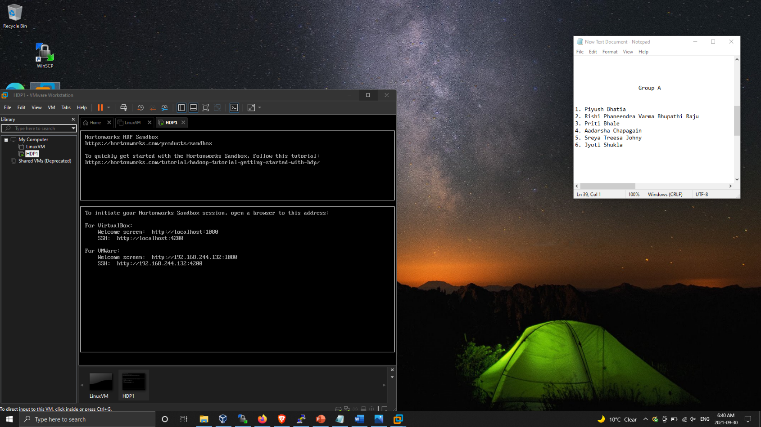

* Creating Sandbox session using Putty.

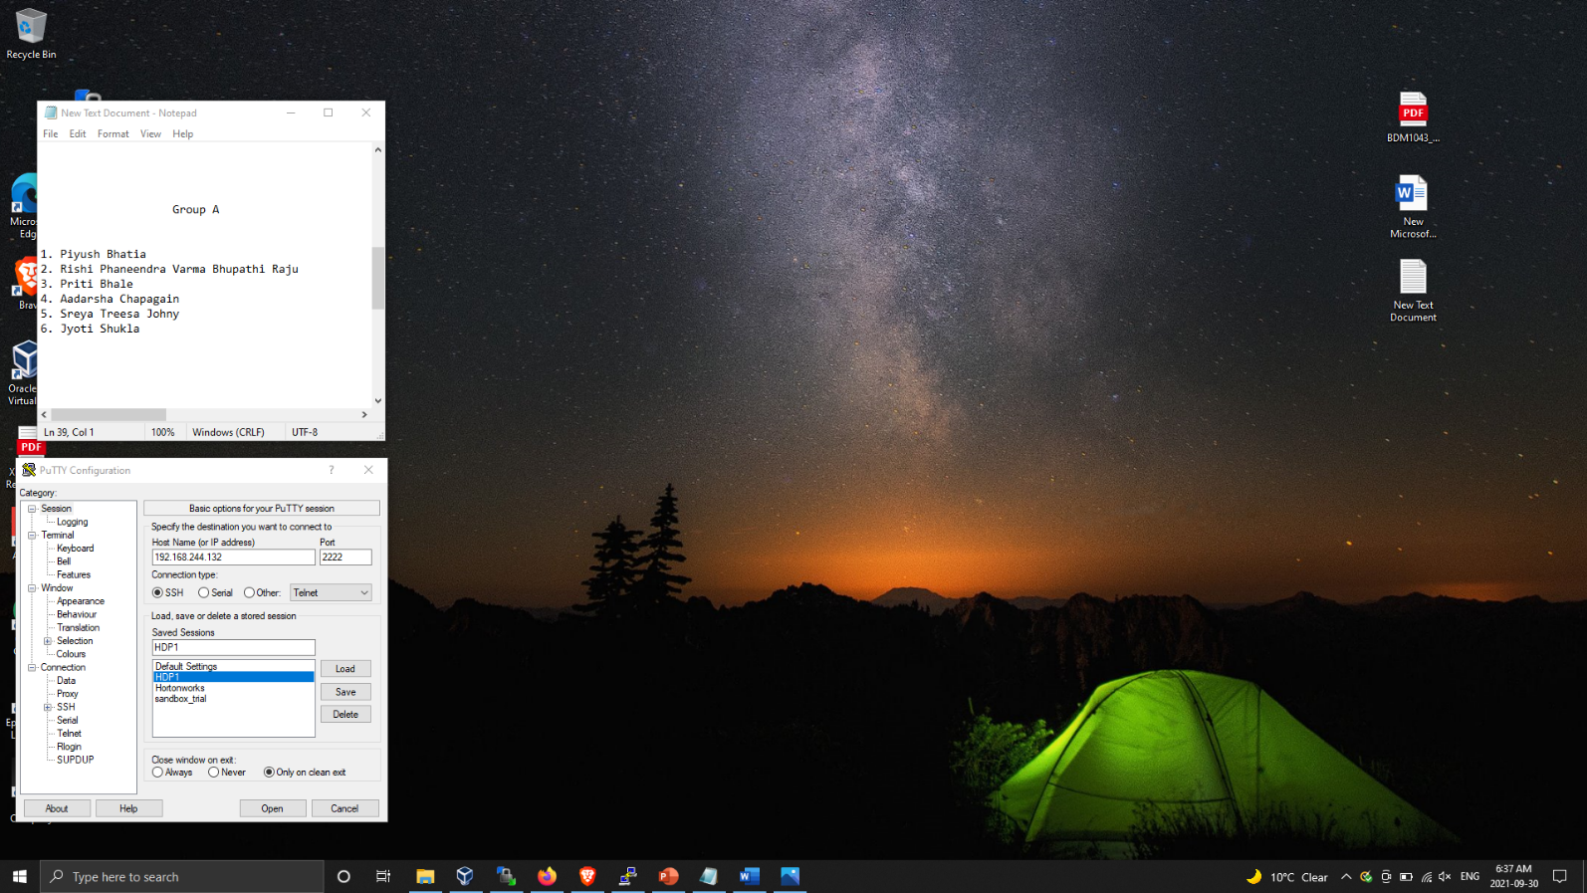

* Transferring “map-reduce-sample.jar” and “SalesJan2009.csv” to /home/hdfs directory using WinSCP.

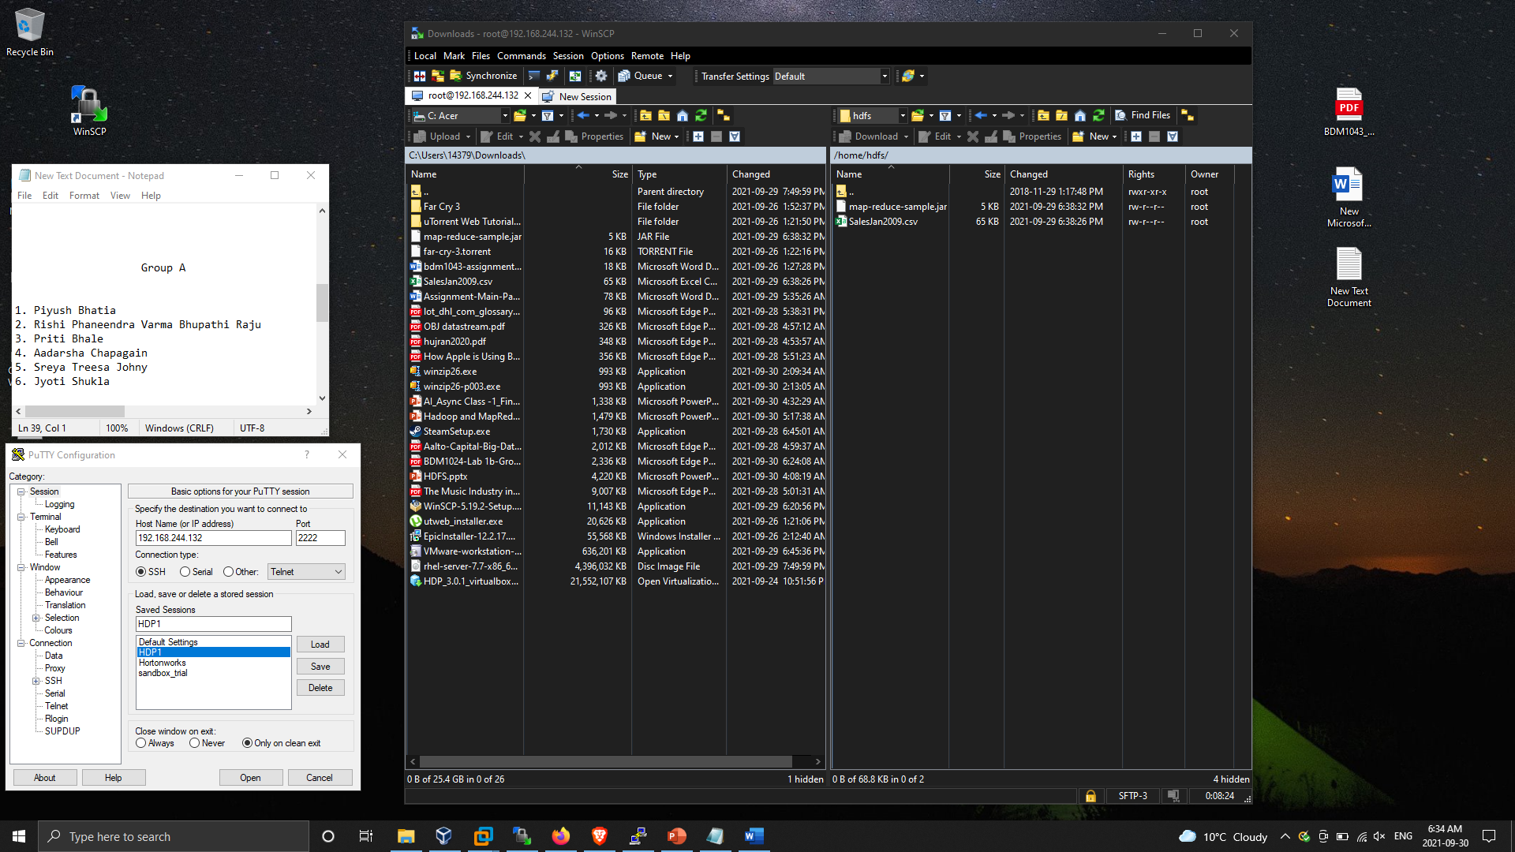

* List of files transferred to our local machine using WinSCP.

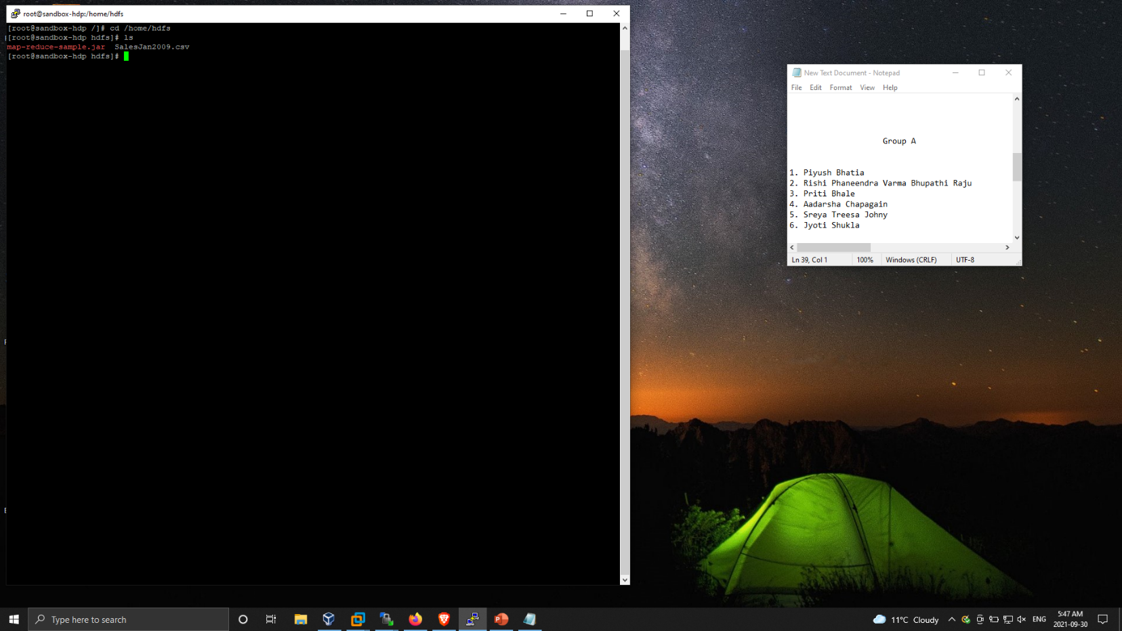

* Implimenting jar file using Hadoop command from input location /testdata and storing the output into /testdata/mp_output.

